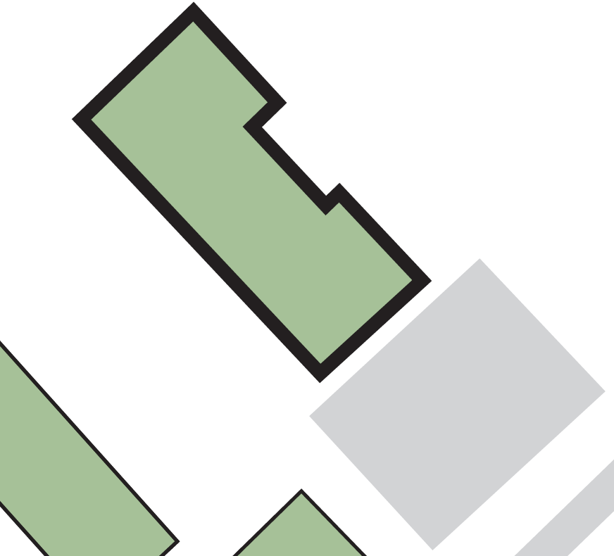

**4**

**PERCY SHAW HOUSE**

**Faith Centre**

**3**

**1**

**2**

**Fire exit from technicians’ office (SHB/02)**

**Exit from basement at rear of the building**

**Ground floor fire exit**

**4**

**3**

**2**

**Its main exit**

**1**

**Assembly point 8 (paved area to the front of the building)**

*Version: May 2021*

**If evacuating the building by:**

**ASSEMBLY POINT LOCATION – PERCY SHAW HOUSE**