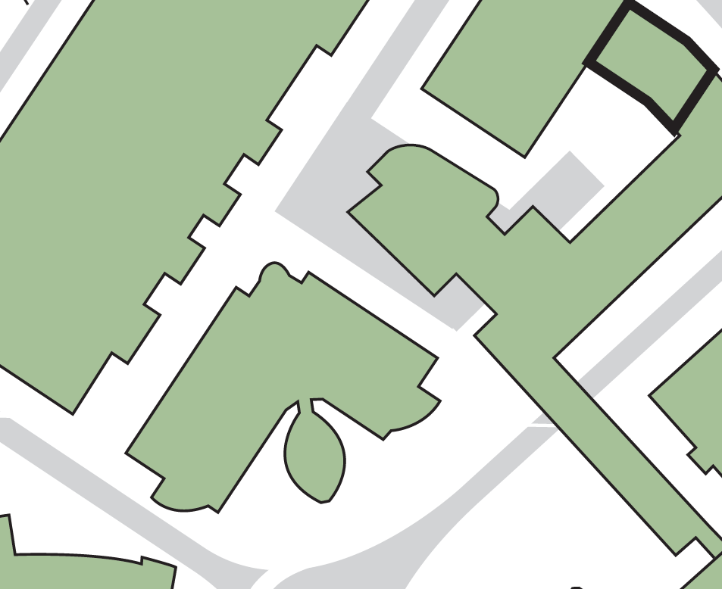

**Evacuating the building by:**

**Its main exit**

**Assembly point 14 (adjacent to Laura Annie Willson Building)**

**1**

**2**

**Fire exit from the main staircase**

**3**

**Exit route into Joseph Priestley South Building staircase**

**Harold Wilson Building**

**3**

**2**

**1**

**JOURNALISM, MEDIA AND FILM BUILDING**

**Joseph Priestley South Building**

**Joseph Priestley East Building**

**Brontë Lecture Theatres**

**Laura Annie Willson Building**

**ASSEMBLY POINT LOCATION – JOURNALISM, MEDIA AND FILM BUILDING**