|  |
| --- |
| **ASSEMBLY POINT LOCATION: RAMSDEN BUILDING** |

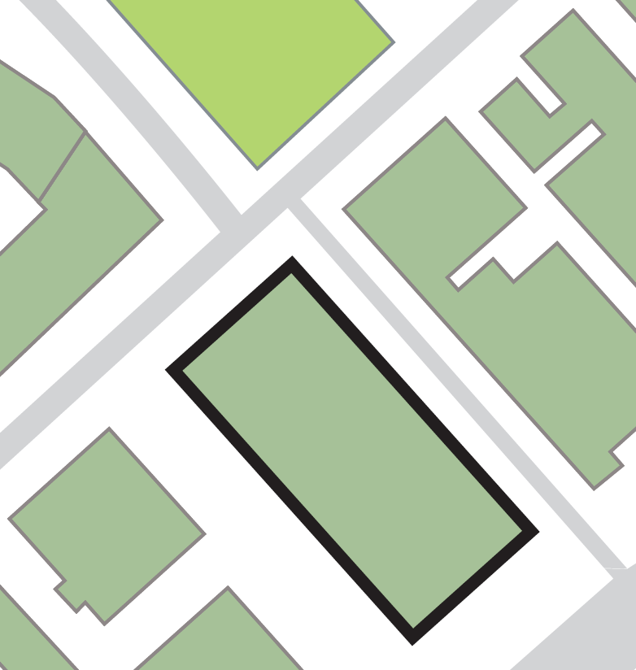

➌

➋

➊

**rAMSDEN**

**BUILDING**

**Sir Patrick Stewart Building**

**Queen Street Building**

**Cockcroft Building**

**Joseph Priestley Building**

|  |  |  |
| --- | --- | --- |
| **Assembly point 12 (area below Queen Street and Sir Patrick Stewart buildings)** | | |
| **Exiting the building by the: -** | | |
|  | **➊** | **Main exit at the front onto the ring road.** |
|  | **➋** | **Glass porch exit, Cockcroft Building-side.** |
|  | **➌** | **Exit onto Page Street.** |